INSTALLATION OF THE GERMINATION TEST ON CORN (Zea mays) SEEDS: COMPARISON OF VACUUM AND MANUAL SYSTEMS

Raquel Mendes de Araújo¹, Amanda Jakelline Dias Araujo², Gustavo Mendes Araújo Fernandes², Gizele Ingrid Gadotti¹, Ruan Bernardy¹, Karine Von Ahn Pinto¹, Rita de Cassia Mota Monteiro¹

¹Universidade Federal de Pelotas – UFPEL, RS. ²Instituto Federal de Educação, Ciência e Tecnologia de Minas Gerais – IFMG, MG. E-mail: ruanbernardy@yahoo.com.br

Abstract
In the corn crop, some challenges interfere with achieving high productivity. Technologies and research contribute to efficient solutions, including seed technology, a fundamental element for good product development. The adoption and diffusion of technologies and agricultural practices significantly affect productivity gains. The objective of this study was to compare the performance of germination test installation in corn using the vacuum system and the manual system. The experiment was conducted in a Quality Control Laboratory in Uberlândia – MG, Brazil. It consisted of two stages. First, a vacuum system was built for this purpose to install the test. A manual system was used in the second installation, using acrylic seed counters. The hypothesis was that the vacuum system is more efficient in test installation capacity since equipment makes the procedure faster. However, flaws in the vacuum instrument were found, requiring adjustments or technological improvements. The results showed that the vacuum system reduced the capacity to install the germination test for corn seeds by 60% compared to the current manual installation system. The system was disapproved, requiring adjustments to reduce the test installation time, ensuring greater efficiency and speed. With this, suggestions for adaptations and improvements to the system will be forwarded.
Keywords: agrotechnology; classification; laboratory; productivity.

INSTALAÇÃO DO TESTE DE GERMINAÇÃO EM SEMENTES DE MILHO (Zea mays): COMPARAÇÃO DOS SISTEMAS A VÁCUO E MANUAL

Resumo
Na cultura do milho são observados desafios que interferem no alcance da alta produtividade. Tecnologias e diversas pesquisas contribuem com soluções eficientes, entre elas a tecnologia de sementes, elemento fundamental para o bom desenvolvimento da produção. A adoção e difusão de tecnologias e práticas agrícolas resultam em efeitos significativos para ganhos de produtividade. O objetivo deste estudo foi comparar o rendimento de instalação do teste de germinação na cultura do milho, utilizando-se o sistema a vácuo e o manual. O experimento foi conduzido em um Laboratório de Controle de Qualidade, situado na cidade de Uberlândia - MG. Constituiu-se em duas etapas. Na primeira, para a instalação do teste, aplicou-se um sistema a vácuo construído especialmente para esta finalidade. Na segunda instalação, foi utilizado o sistema manual, empregando-se contadores de sementes em acrílico. A hipótese apresentada foi que o sistema a vácuo é mais eficiente quanto à capacidade de instalação do teste, visto que a utilização de equipamentos torna o procedimento mais rápido. Porém, foram encontradas falhas relacionadas ao instrumento a vácuo, sendo necessários ajustes ou mesmo melhorias da tecnologia. Os resultados evidenciaram que o sistema a vácuo reduziu a capacidade de instalação do teste de germinação para sementes de milho em 60%, quando comparado com o sistema atual de instalação manual. O sistema foi reprovado, necessitando de ajustes para reduzir o tempo de instalação do teste, garantindo maior eficiência e rapidez. Com isso, serão encaminhadas sugestões de adaptações e melhorias no sistema.
Palavras-chave: agrotecnologia; classificação; laboratório; produtividade.

Introduction
Brazil stands out in agricultural and seed production, especially corn and soybeans. This situation is favored by the country's climatic conditions and advanced technologies (BORGES et al., 2019).
The 2017/2018 crop survey listed 298 corn seed cultivars, including corn grain, silage, popcorn, and sweet corn. Of these, 195 were transgenic, 103 were conventional, meaning 65.43% of the cultivars were transgenic, and only 34.56% were conventional. Using seeds with transgenic events is becoming increasingly common in Brazilian crops because of the lower production cost or the practicality in crop management (PEREIRA FILHO; BORGHI, 2018).
In Brazil, corn is an agricultural crop considered strategic due to its versatility, presenting characteristics such as broad adaptability and productive stability (MIRANDA et al., 2021). In addition, the cereal expanded the country's agribusiness, corresponding to a considerable part of Brazilian grain production.
Corn is used as a raw material in several production chains, used in the manufacture of animal feed and the food industry (consumed in natural or processed in the form of flour, flakes, popcorn, germ, and starch). It is also used for beer fermentation, biofuel production, food coloring, and the pharmaceutical industry (SANTOS; BALDONI, 2018).
Due to the importance of this cereal, several companies and government agencies have developed seed technologies to increase production levels. Thus, tests are carried out to identify seed lots to reach a certain quality standard (SANTOS; BALDONI, 2018). Seed quality is crucial because it determines good production and crop success (MACIEL; TUNES, 2021). Therefore, it is necessary to evolve technologies and knowledge and develop research and innovations that improve productivity, proposing efficient solutions (CONTINI et al., 2019).
In this context, seed technology is a fundamental element for production development. Seed technology comprises techniques whose objectives are to adapt or create specific techniques, improving the seed's quality standard (BIANCHETTI, 1981).
The analyses express the real potential of the seeds, guaranteeing a better improvement and refinement of management and production techniques with high quality, resulting in crop competitiveness and increased production (FRANÇA-NETO et al., 2016).
Laboratories are essential for production growth, responsible for identifying the quality of the marketed product (BORGES et al., 2019). Initially, quality was evaluated visually, and with the intensification of trade, problems arose due to the contamination of the lots, reducing the commercial value. These practices stimulate the need for detailed quality examinations and the creation of laboratories to certify this quality (UFSM, 2020a).
Among the tests performed in the laboratory, the germination test is the one that stands out the most in the world community of researchers in seed technology. It is the most used by manufacturing companies and is mandatory in certification processes for marketing purposes (PERES, 2010). This standard is out among the techniques related to seeds due to its importance in choosing the cultivar to be implanted in the crop. The germination analysis guarantees the quality of the seed and, consequently, the crop's success (MACIEL; TUNES, 2021).
In support of carrying out numerous germination tests in a laboratory, there is the vacuum counter, which is probably the fastest and most common way of counting seeds in the laboratory. It is made of an acrylic (or sometimes metal) plate, perforated with 25, 50, or 100 holes, and attached to a second hollow plate. The seeds are spread loosely in a 1 cm deep layer to use the vacuum counter. Next, the counter is placed over the seeds, activating the equipment. With the vacuum still on, the seeds can be transferred to a weighing pan or germination vessel (KARRFALT, 2008).
This study is justified due to the high demand for analysis in seed quality laboratories. There is a need to perform high volumes of analysis; therefore, automating processes is essential.
Thus, the objective of this study was to evaluate the performance of the installation of the germination test in the corn crop using vacuum and manual systems to seek the most efficient seed distribution on the counting plate, with efficiency concerning the time for installation of the germination test.
Material And Methods
The experiment was conducted in a Quality Control Laboratory in Uberlândia - MG, Brazil. Seeds of several corn hybrids produced in the 2021 summer crop were used.
Currently, the test can be installed using the manual or vacuum system. In the manual system, counting is performed using acrylic counters with a capacity of 50 seeds. In the vacuum system, counting is performed with perforated plates with 100 micro holes.
In the present work, the experiment consisted of two stages. First, for the installation of the test, a vacuum system built especially for this purpose was used (Figures 1 and 2).

Figure 1. Vacuum system for counting seeds
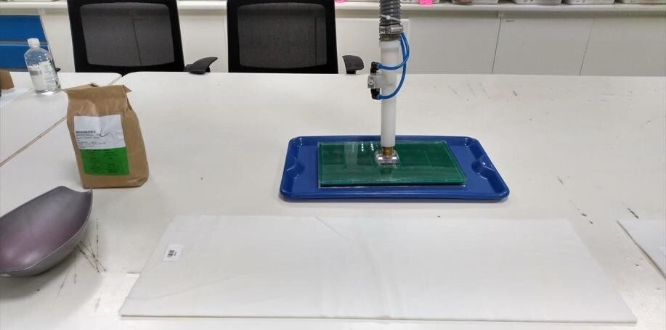
.
Figure 2. A) Vacuum system for seed counting (seed suction). B) Vacuum system for seed counting (seed release on the plate).
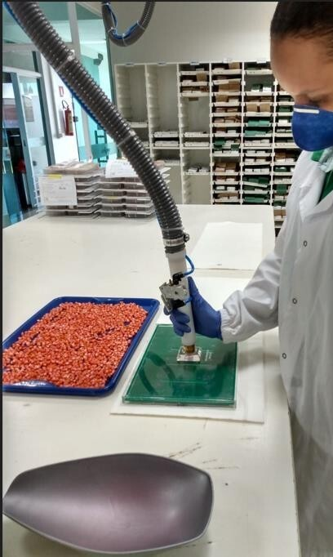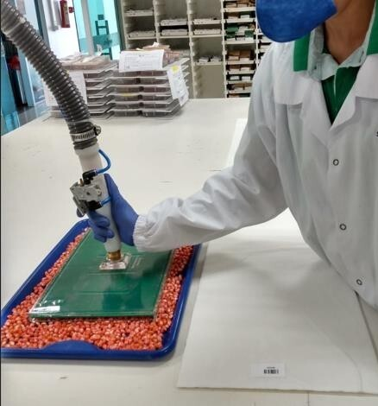
(A)
(B)
The manual system was used in the second installation using acrylic seed counters. Germination can be tested in the laboratory. The seeds are submitted to laboratory analysis under controlled conditions that allow regular, rapid, and complete germination of samples of certain species to determine the maximum potential of a lot. The procedure helps compare quality and estimate the value for sowing in the field (UFSM, 2022b). The test was conducted as shown in Figures 3 and 4.

Figure 3. Manual system for counting seeds.
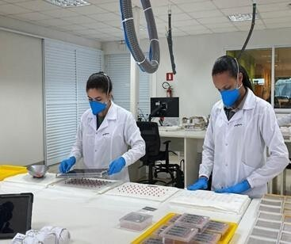

Figure 4. Tray for manual seed counting.
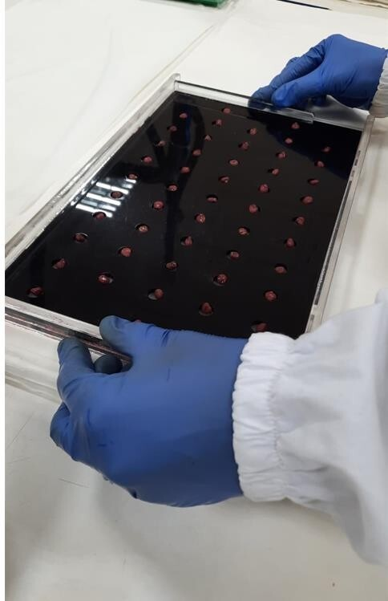
In the laboratory, temperature, humidity, oxygenation, and luminosity are adjusted to meet what the seed needs to develop (ISTA, 2022). Then, these conditions are standardized to reproduce and compare results (UFSM, 2022b).
Three pairs of seed analysts who have worked at the company for at least two years in the testing facilities sector were dimensioned, all with experience in the manual installation and who showed better resourcefulness in using the vacuum system. Each pair performed the assembly of 30 repetitions in each system. The performance of employees was timed (in seconds), using time as a variable to verify the ability to install the test on each system.
The t-test was performed at 5% significance, first considering pairs to compare the means between the systems. Then, an evaluation of events and failures was carried out for greater detailing of the potential or not of the systems.

Results And Discussion
Laboratory tests determine seeds lot quality, certify their value for sowing, provide data for labeling and inspection of trade, establish bases for purchase and sale, as well as for distribution, storage, or disposal, evaluate the processing, help research and genetic improvement and identify problems and possible causes (UFSM, 2020a). In addition, the growth in seed production resulted in an increase in laboratory demands for analysis due to the need to issue a bulletin for commercialization and internal quality controls (BORGES et al., 2019).
Germination is the ability to originate a new seedling, the embryo being the essential structure to generate the root system, coleoptile, and shoot. In the laboratory, it is ideal to obtain good development in the field under favorable conditions (MACEDO et al., 2016). According to the International Seed Testing Association (ISTA, 2022), it is characterized by the emergence and development of a normal seedling that presents its essential structures well-developed in ideal conditions for carrying out the test.
Regarding the test, Karrfalt (2008) comments that sowing can occur in several ways, using manual or automated ways. Although, for example, seeding plates or vacuum counters can be used, both must allow for uniform seed spacing.
The t-test analysis to compare the germination evaluation's average installation time indicated a time difference (in seconds) between the systems (Table 1). It was possible to notice that the time of the manual system differs statistically from the vacuum system, requiring a shorter installation time using the first Equating the manual method with the vacuum system.

Table 1. Installation time in seconds of the systems using the general averages of the pairs.
Systems | Average
Manual | 177,7a
Equipment | 320b

Generally, in the manual system, it takes 7 to 22 days to obtain results that can be used by seed suppliers and/or buyers (ISTA, 2022). Karrfalt (2008) explains that a lot with 80% germination can produce just 80 plants per 100 seeds. Therefore, if 100 plants are needed, at least 125 seeds should be sown (100/0.80 = 125).
In terms of efficiency and practicality, the counting tray may be slower than manual counting, depending on the size and shape of the genetic material. The manual tray is like the counting tray, but the former is emptied by sliding the lower tray instead of turning it over. Using either method can change the counting speed considerably for uniformly sized seeds.
It was observed that there was also a significant difference between the systems (Table 2), analyzing the pair average between the techniques. For both pairs, the manual method required a shorter installation time. It was observed that pair 1 performed better in installing the manual germination test and using the equipment, followed by Class 2 and Class 3, respectively. This situation can be justified because pair three was formed by new collaborators, and pair one by more experienced collaborators.

Table 2. Average assembly pairs in seconds between counting systems. Source: Authors, 2022.
Pairs | Manual | Equipment
Pair 1 | 134,7a | 216,9b
Pair 2 | 166a | 309,5b
Pair 3 | 232,4a | 432,2b

It is essential to compare the two systems to verify the viability of each. This comparison is beneficial when applied to companies dedicated to developing technologies, research, seed production, and quality analysis of the lots that will be marketed. Furthermore, automation is already recurrent in agriculture, as an example, the use of image fissure assessments (MONTEIRO et al., 2022) in recognition of vigor (ABUD et al., 2017; GONÇALVES et al., 2017; MARCHI; GOMES JUNIOR, 2017; SILVA et al., 2017b; TRUJILLO et al., 2019; PEREIRA et al., 2020; RODRIGUES et al., 2020; REGO et al., 2021), of morphology and physiological potential through X-ray and image analysis (CATÃO; CAIXETA, 2017; LEÃO-ARAÚJO et al., 2017; JAVORSKI; CICERO, 2017; SILVA et al., 2017a; ABUD et al., 2018; JAVORSKI et al., 2018; MEDEIROS et al., 2018; MEDEIROS et al., 2019; SILVA et al., 2020; LEITE et al., 2020; MEDEIROS et al., 2020; RIBEIRO et al., 2021; ABUD et al., 2022). The automated germination test facility is in line with other processes, increasingly affirming technology's contributions to improving the sector, considering the need to automate processes to meet the growing demand for testing, and comparing the two methods allowed identifying events that disqualified the vacuum system. Table 3 presents the events and the respective failure identified in the vacuum technique related to the automation of the equipment.

Table 3. Events and failures in the automation of the counting system.
Event | Failure
The vacuum system does not support some seeds equal to or less than 250 g, unable to perform the task. | The vacuum equipment needs to be fully automated, requiring manual operator intervention.
After the seed is sucked, it is necessary to check that the counter is complete before dropping them on the paper to ensure that no seeds are missing at the installation time.
When changing the sample, it is necessary to clean the seed counter, ensuring that seeds from the previous sample are not retained in the equipment and a possible mixing occurs between them (sample crossing).
When dropping the seed on the Germitest paper, the vacuum system encounters the leaf and condenses the water on the suction plate, leaving it wet; being necessary to dry it before going to the following sample.
A vacuum system holds more than one seed in the same hole if it is small.
Tap lightly to fully release the seed from the counter because they take time to come off due to its shape (flattened, pointed, large).

It is essential to highlight an attempt to invert the suction plate upwards and place the seeds on it before activating the equipment, ensuring all holes were filled. However, the procedure was not considered for ergonomic reasons.
It is suggested to improve the technology to ensure the entire process is automated, reducing or eliminating the need for operator intervention to correct the above-mentioned events. In addition, automation offers improvements in installing germination tests in the laboratory.
Automation has advantages such as replacing workers in heavy, monotonous tasks and hazardous environments, providing ease of handling small elements, faster production with lower labor costs, ease of inspections and verifications, and reducing non-standard products (LAMB, 2015).
In Table 4, the event and the respective failure related to the speed aspect of the process were raised.

Table 4. Event and failure regarding the speed of the counting process.
Event | Failure
In tiny seeds with flat or pointed shapes, sowing with the vacuum system is slower than with the manual system. | Vacuum equipment needs to offer the necessary agility to the process.

Making plates with smaller holes is suggested to allow the accommodation and suction of small, flat, or pointed seeds to correct the above event.
Ensuring the speed of the process is also a way of guaranteeing quality. Qualitative systems depend on the use of modern tools and techniques. The final product of any quality process is influenced by several factors related to each other by causes and effects. This relationship can be verified using administrative quality control tools, such as the Cause-and-Effect Diagram and Quality Control Circles, which effectively discuss the functioning of a process or problem presented (TILLMANN; GADOTTI, 2015). Regarding the dimension aspect, Table 5 presents the observed event related to the dimension of the vacuum suction plate.

Table 5. Event and failure on the dimension of the counting equipment.
Event | Failure
The spacing between the rows in the tray used in the vacuum does not guarantee enough space to fold the paper, leaving the elastic on top of the seed, which may affect the seedling development. | The trays used in the vacuum equipment need a dimension compatible with the paper size.

Here, it is recommended to make new plates, allowing the proper positioning of the seeds on the paper and not interfering with the development of the seedlings. On the aspect of worker safety and health, in addition to increasing person-hour productivity, Table 6 discusses ergonomics.

Table 6. Event and failure that affect ergonomics at work during the installation of the germination test.
Event | Failure
Regarding ergonomics, the hoses are shorter and do not reach the paper without forcing it. In addition, they need more flexibility, requiring the operator to exert physical force to move the vacuum from the tray to the paper. For employees of short stature, this can lead to low back, back, arm, and hand pain. | The vacuum equipment hoses need to be longer, and the material with which they were built makes the process unfeasible.

The suggestion presented in this aspect is improving the operator's performance by adapting equipment parts (length of some hoses, a pipe with lighter and more flexible material). In addition, it is necessary to establish a usage routine for employees to adapt to the equipment.
Brazilian Regulatory Standard No. 17 (NR-17), in its item 17.4.6, describes that the dimensions of the workspace by task must be sufficient for the worker to move the body segments freely, facilitate the work and reduce the employee effort, not requiring extreme adoption or harmful postures (BRASIL, 2022). Therefore, such equipment violates this legislation.
The disharmony between the worker and his work environment (lack of comfort, safety, and efficiency in his activities) causes ergonomic risks. For example, in seed and grain treatment units, such disharmony is associated, among other causes, with cargo handling, poor lighting, excessive working hours, and general disturbances that impair employee comfort. Therefore, ergonomics should be considered when sizing equipment, for example, facilitating operations and promoting a safe and efficient work environment (GADOTTI et al., 2015).
Regarding the installation capacity of the Corn Germination Test (GN Corn), Table 7 shows the total analysis performed in the laboratory in question, carried out between January and March 2022, as well as estimates the reduction in the capacity of the evaluations if the vacuum system is used as it is.

Table 6. Comprehensive analyses capable of using the vacuum system from January to March 2022.
GN Corn | January | February | March
GN Corn | 2051 | 1964 | 1960
Estimated capacity reduction (60%) | 1231 | 1179 | 1176

The emergence is influenced by environmental factors such as temperature, humidity, and substrate. The laboratory can manipulate the environmental factors to optimize germination percentage, speed, and uniformity (GUIMARÃES, 1999). In this environment, the seeds are supplied with water by absorption through substrates such as paper, cloth, sand, or soil. The humidity condition determines the oxygen supply, while the substrate works as a physical support for the development of the seedlings (MACHADO, 2002).
Temperature is one of the most critical factors in germination (NERSON, 2017) since it influences the absorption of water and other essential substrates for the growth and development of seedlings (SBRUSSI; ZUCARELI, 2014). Its effects on the germination process can be evaluated from changes in germination percentage, speed, and uniformity (MARCOS FILHO, 2005). The substrate must provide sufficient moisture throughout the test to ensure that the germination process occurs entirely. Water deficiencies make it impossible to proceed with the biochemical, physical, and physiological processes crucial for embryo growth resumption. However, it cannot be excessive so as not to limit and impair aeration (ISTA, 2022). Phaneendranath (2000) observed that oxygen restrictions could cause delay or paralysis in the development of seedlings, which can lead to abnormalities (absence of roots and formation of hyaline seedlings).
Using the equipment in the current conditions will reflect a reduction of the test installation capacity of 60% of the current efficiency. This reduction is due to the more significant time spent on installing the test and the need for manual operator intervention. This interference occurs checking vacuum suction to see if all holes plate were filled and if the seeds were released on the paper. In addition, the employee will also spend more time drying the suction plate after putting it in contact with the Germitest paper. Alves et al. (2015) state that knowing the conditions that provide rapid and uniform germination helps to promote more consistent growth in the field.

Conclusions
Faults related to the vacuum equipment were found, making it necessary to understand the difficulties related to the system and propose improvement solutions.
The need to adjust or even improve the technology used for the proper functioning of the technique was observed, meeting the need for automation of processes in the laboratory, implying meeting the demand promptly.
The results did not correspond to the need to automate processes in terms of efficiency and effectiveness, showing a reduction in the capacity to install the germination test for corn seeds by 60% when compared to the current system of manual installation. The system was disapproved, requiring adjustments to reduce the test installation time, ensuring greater efficiency and speed. With this, suggestions for adaptations and improvements to the system will be forwarded.

References
ABUD, H. F.; CICERO, S. M.; GOMES JUNIOR, F. G. Computerized image analysis of seedlings to evaluate broccoli seed vigor. Journal Of Seed Science, v.39, n.3, p.303-310, set. 2017. http://dx.doi.org/10.1590/2317-1545v39n3174582.

ABUD, H. F.; CICERO, S. M.; GOMES JUNIOR, F. G. Radiographic images and relationship of the internal morphology and physiological potential of broccoli seeds. Acta Scientiarum. Agronomy, v.40, n.1, p.34950, 2018. http://dx.doi.org/10.4025/actasciagron.v40i1.34950.

ABUD, H. F.; MESQUITA, C. M. S.; SARMENTO, E. C. S.; MELO, R. S.; LIMA, K. A. P.; SILVA, A. K. F. Image analysis of the seeds and seedlings of Vigna radiata L. Revista Ciência Agronômica, v.53, p.e20207303, 2022.

ALVES, C. Z.; SILVA, J. B.; CÂNDIDO, A. C. S. Methodology for carrying out the germination test in guava seeds. Revista Ciência Agronômica, v.46, n.3, p.615-621, 2015. http://dx.doi.org/10.5935/1806-6690.20150045.

BIANCHETTI, A. Tecnologia de sementes de essências florestais. Revista Brasileira de Sementes, v.3, n.3, p.27-46, 1981. https://doi.org/10.17801/0101-3122/rbs.v3n3p27-46

BORGES, A.; FELÍCIO, T. P.; SEVERO, J. A.; AGUIAR, C. C.; POPP, T. R. Estudo de mercado para a implantação de um laboratório de análises de sementes na Unoesc de Campos Novos. Unoesc & Ciência - ACET, v.10, n.2, p.107–114, 2019.

BRASIL. Lei nº 17, de 28 de novembro de 2018. Norma Regulamentadora No. 17 (Nr-17). Brasília: Ministério do Trabalho e Previdência, 07 mar. 2022. https://www.gov.br/trabalho-e-previdencia/pt-br/composicao/orgaos-especificos/secretaria-de-trabalho/inspecao/seguranca-e-saude-no-trabalho/ctpp-nrs/norma-regulamentadora-no-17-nr-17

CATÃO, H. C. M.; CAIXETA, F. Physiological, isozyme changes and image analysis of popcorn seeds submitted to low temperatures. Journal Of Seed Science, v.39, n.3, p.234-243, 2017. http://dx.doi.org/10.1590/2317-1545v39n3169853.

CONTINI, E.; MOTA, M. M.; MARRA, R.; BORGHI, E.; MIRANDA, R. A.; SILVA, A. F.; SILVA, D. D.; MACHADO, J. R. A.; COTA, L. V.; COSTA, R. V.; MENDES, S. M. Milho: caracterização e desafios tecnológicos. Embrapa, 2019. p.1-45.

FRANÇA-NETO, J. B.; KRZYZANOWSKI, F. C.; HENNING, A. A.; PÁDUA, G. P.; LORINI, I.; HENNING, F. A. Tecnologia da produção de semente de soja de alta qualidade. Londrina: Embrapa Soja, 2016. 82p.

GADOTTI, G. I.; OLIVEIRA, A. L.; LUZ, M. L. G. S.; TILLMANN, C. A. C. Saúde e segurança do trabalho em unidades beneficiadoras de grãos e sementes. Pelotas: Santa Cruz, 2015.

GONÇALVES, N. R.; CICERO, S. M.; ABUD, H. F. Seedling image analysis and traditional tests to evaluate onion seed vigor. Journal Of Seed Science, v.39, n.3, p.216-223, 2017. http://dx.doi.org/10.1590/2317-1545v39n3160444.

GUIMARÃES, R. M. Fisiologia de sementes. Lavras: UFLA, 1999.

ISTA. International Rules for Seed Testing. Switzerland: International Seed Testing Association, 2022.

JAVORSKI, M.; CASTAN, D. O. C.; SILVA, S. S.; GOMES-JUNIOR, F. G.; CICERO, S. M. Image analysis to evaluate the physiological potential and morphology of pearl millet seeds. Journal Of Seed Science, v.40, n.2, p.127-134, 2018. http://dx.doi.org/10.1590/2317-1545v40n2176904.

JAVORSKI, M.; CICERO, S. M. Utilização de raios x na avaliação da morfologia interna de sementes de sorgo. Revista Brasileira de Milho e Sorgo, v.16, n.2, p.310, 2017. http://dx.doi.org/10.18512/1980-6477/rbms.v16n2p310-318.

KARRFALT, R. Seed Testing. In: BONNER, F. T.; KARRFALT, R. The woody plant seed manual. United States: Forest Service, 2008. p. 97-116.

LAMB, F. Automação industrial na prática. Porto Alegre: AMGH, 2015.

LEÃO-ARAÚJO, E. F.; SANTOS, J. F.; SILVA, C. B.; MARCOS-FILHO, J.; VIEIRA, R. D. Controlled deterioration test and use of the Seed Vigor Imaging System (SVIS ®) to evaluate the physiological potential of crambe seeds. Journal Of Seed Science, v.39, n.4, p.393-400, 2017. http://dx.doi.org/10.1590/2317-1545v39n4177911.

LEITE, M. S.; TORRES, S. B.; GOMES JUNIOR, F. G.; REGO, C. H. Q.; PAIVA, E. P.; LEITE, T. S. Viability of seedling image analysis (Vigor-S) to determine the physiological potential of melon seeds. Journal Of Seed Science, v.42, p.e202042043, 2020. http://dx.doi.org/10.1590/2317-1545v42237826.

MACEDO, D. X. S.; SANTOS, V. C.; VIEIRA, J. M.; CARVALHO, J. A. D.; ALBIERO, D. Teste de germinação na cultura do milho. Revista Cultivar, 2016.

MACHADO, C. F. Metodologia para condução do teste de germinação e utilização de raios-X para a avaliação da qualidade de sementes de aroeira branca (Lithraea molleoides (Vell.) Engl.). 2002. Dissertação (Mestrado em Agronomia) - Escola Superior de Agricultura Luiz de Queiroz, Piracicaba, 2002.

MACIEL, L. M.; TUNES, L. V. M. A importância do controle de qualidade nas sementes de milho. Brazilian Journal of Development, v.7, n.5, p.49934-49938, 2021.

MARCHI, J. L.; GOMES JUNIOR, F. G. Use of image analysis techniques to determine the embryo size of Senna multijuga (Rich.) seeds and its relation to germination and vigor. Journal Of Seed Science, v.39, n.1, p.13-19, 2017. http://dx.doi.org/10.1590/2317-1545v39n1165423.

MARCOS-FILHO, J. Fisiologia de sementes de plantas cultivadas. Piracicaba: FEALQ, 2005.

MEDEIROS, A. D.; ARAÚJO, J. O.; LEÓN, M. J. Z.; SILVA, L. J.; DIAS, D. C. F. S. Parameters based on X-ray images to assess the physical and physiological quality of Leucaena leucocephala seeds. Ciência e Agrotecnologia, v.42, n.6, p.643-652, 2018. http://dx.doi.org/10.1590/1413-70542018426023318.

MEDEIROS, A. D.; MARTINS, M. S.; SILVA, L. J.; PEREIRA, M. D.; LEÓN, M. J. Z.; DIAS, D. C. F. S. X-ray imaging and digital processing application in non-destructive assessing of melon seed quality. Journal Of Seed Science, v.42, p.e202042005, 2020. http://dx.doi.org/10.1590/2317-1545v42229761.

MEDEIROS, A. D.; SILVA, L. J.; CAPOBIANGO, N.P.; FIALHO, C.A.; DIAS, D. C. F. S. Assessing the physiological quality of common bean seeds using the Vigor-S® system and its relation to the accelerated aging test. Journal Of Seed Science, v.41, n.2, p.187-195, abr. 2019. http://dx.doi.org/10.1590/2317-1545v41n2211401.

MIRANDA, R. A.; BORGHI, E.; KARAM, D.; GONTIJO NETO, M. M.; TRINDADE, R.S.; RESENDE, Á. V.; OLIVEIRA, I. R.; PARENTONI, S. N.; MENDES, S. M.; DUARTE, J. O.. Aumento de produtividade e rentabilidade de milho com intensificação tecnológica. In: TELHADO, S. F. P.; CAPDEVILLE, G. (eds.). Tecnologias poupa-terra. Brasília: Embrapa Milho e Sorgo, 2021. p.77-112.

MONTEIRO, R. C. M.; GADOTTI, G. I.; VILLELA, F. A.; CARDOSO, J. T. C.; OLIVEIRA, M. Métodos de identificação de fissuras em sementes de arroz após a secagem artificial. Revista Engenharia Agrícola, v.42, esp., 2022. https://doi.org/10.1590/S0103-84782005000500033

PEREIRA FILHO, I. A.; BORGHI, E. Sementes de milho no Brasil: a dominância dos transgênicos. Sete Lagoas: Embrapa Milho e Sorgo, 2018.

PEREIRA, M. D.; REIS, J. A.; FERRARI, C. S.; VALE, A. M. P. Processamento digital de imagens de plântulas na avaliação do vigor de sementes de Moringa oleifera Lam. Ciência Florestal, v.30, n.2, p. 291, 2020. http://dx.doi.org/10.5902/1980509825750.

PERES, W. L. R. Testes de vigor em sementes de milho. 2010. Dissertação (Mestrado em Produção e Tecnologia de Sementes) - Faculdade de Ciências Agrárias e Veterinárias, Universidade Estadual Paulista, Jaboticabal, 2010.

PHANEENDRANATH, B.R. Influence of amount of water in the paper towel on standard germination tests. Journal of Seed Technology, v.5, n.2, p.82-87, 2000.

REGO, C. H. Q.; CICERO, S. M.; FRANÇA-SILVA, F.; GOMES-JUNIOR, F. G. Assessing the vigor of cowpea seeds using the Vigor-S software. Journal Of Seed Science, v.43, p.e202143018, 2021. http://dx.doi.org/10.1590/2317-1545v43244858.

RIBEIRO, A. S.; NERI, T. F. S.; MEDEIROS, A. D.; MILAGRES, C. C.; SILVA, L. J. Use of radiographic images for rapid and non-destructive assessment of crambe seed quality. Journal Of Seed Science, v.43, p.e202143001, 2021. http://dx.doi.org/10.1590/2317-1545v43239136.

RODRIGUES, M.; GOMES-JUNIOR, F. G.; MARCOS-FILHO, J. Vigor-S: system for automated analysis of soybean seed vigor. Journal Of Seed Science, v.42, p.e202042039, 2020. http://dx.doi.org/10.1590/2317-1545v42237490.

SANTOS, D. M.; BALDONI, A. Avaliação da qualidade fisiológica de sementes de milho. GETEC, v.7, n.19, p.19-30, 2018.

SBRUSSI, C. A. G.; ZUCARELLI, C. Germinação de sementes de milho com diferentes níveis de vigor em resposta à diferentes temperaturas. Semina: Ciências Agrárias, v.35, n.1, p.215-226, 2014. https://doi.org/10.5433/1679-0359.2014v35n1p215

SILVA, J. A.; MEDEIROS, A. D.; PEREIRA, M. D.; RAMOS, A. K. F.; SILVA, L. J. Seed quality analysis of Senna siamea Lam. using image analysis techniques. Journal Of Seed Science, v.42, p.e202042042, 2020. http://dx.doi.org/10.1590/2317-1545v42241633.

SILVA, L. A.; SALES, J. F.; NEVES, J. M. G.; SANTOS, H. O.; SILVA, G. P. Radiographic image analysis of Anacardium othonianum Rizz (anacardiaceae) achenes subjected to desiccation. Acta Scientiarum. Agronomy, v.39, n.2, p.235, 2017a. https://doi.org/10.4025/actasciagron.v39i2.32484 .

SILVA, P. P.; BARROS, A. C. S. A.; MARCOS-FILHO, J.; GOMES JUNIOR, F. G.; NASCIMENTO, W. M. Assessment of squash seed vigor using computerized image analysis. Journal Of Seed Science, v.39, n.2, p.159-165, 2017b. https://doi.org/10.1590/2317-1545v39n2171177.

TILLMANN, C. A.; GADOTTI, G. I. Gestão da qualidade: uma visão para grãos e sementes. Pelotas: Gráfica Santa Cruz, 2015.

TRUJILLO, H. A.; GOMES-JUNIOR, F. G.; CICERO, S. M. Digital images of seedling for evaluating coffee seed vigor. Journal Of Seed Science, v.41, n.1, p.60-68, 2019. http://dx.doi.org/10.1590/2317-1545v41n1204651.

UFSM. Análise de sementes. Santa Maria: Universidade Federal de Santa Maria, 2020a.

UFSM. Teste de germinação. Santa Maria: Universidade Federal de Santa Maria, 2020b.

